Sri Lanka Institute of Information Technology



Research Project

IT4010

B.Sc. (Hons) in Information Technology

Status Document - 02

Group ID: 24-091

Registration Number: IT20619558

Full Name: Samarakkody G.K.G.D.A

Specialization: Data Science

Table of Contents

Contents

1. WORK BREAKDOWN STRUCTURE 3

2. GANTT CHART 4

3. TEAMS PLANNER 5

TEAMS PLANNER BOARD 6

TEAMS PLANNER CHART 6

SCHEDULE 8

4. MEETINGS 9

MEETINGS WITH THE SUPERVISOR (MR. SAMADHI RATHNAYAKE) 9

MEETINGS WITH THE CO-SUPERVISOR (DR Dharshana Kasthurirathna) 12

# 

# WORK BREAKDOWN STRUCTURE

The work breakdown structure entails breaking down a project or task into smaller, more manageable parts in a hierarchical manner. The work breakdown structure plan for the research project's timeline is presented below.

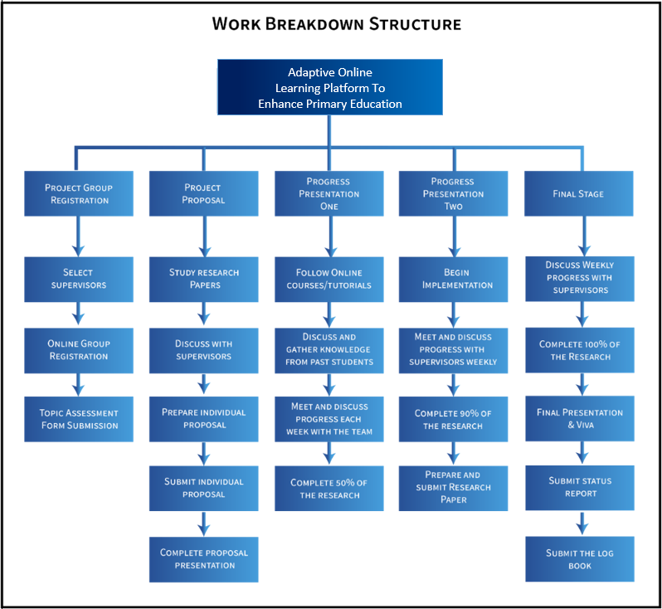

# GANTT CHART

A Gantt chart is a popular project management tool used to visualize the schedule and progress of tasks or activities over time. The Gantt chart which we designed to plan our progress is as shown in the following diagram.

# TEAMS PLANNER

Microsoft Teams Planner serves as an integrated project management and task monitoring tool within the Microsoft Teams collaborative environment. We leveraged this platform to streamline the organization, delegation, and monitoring of tasks, facilitating efficient teamwork and project management.

## TEAMS PLANNER BOARD

The following interface provides a visual representation of tasks using a Kanban board-style layout. It offers a more visual and intuitive way to manage and track tasks within a project.

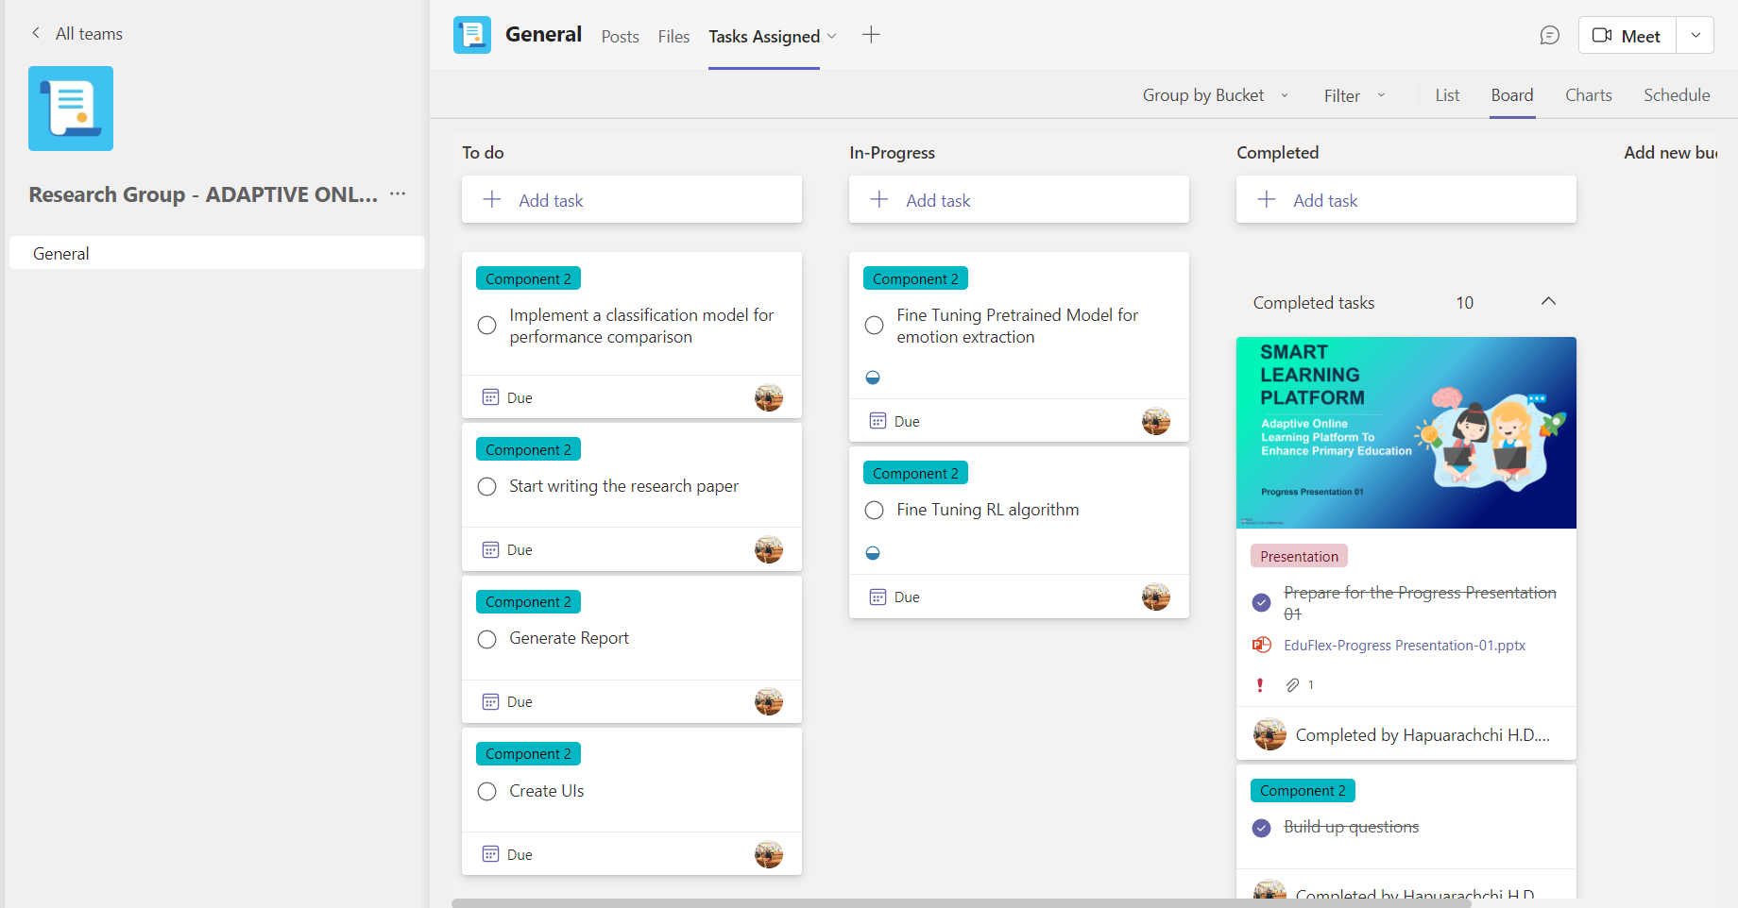

## TEAMS PLANNER CHART

The following chart gives an overview of the current progress of the task list as a graphical representation.

## SCHEDULE

In Microsoft Teams Planner, you can schedule tasks and set due dates to create a timeline for your project or plan. The following calendar shows an overview of a few of the important dates that are set for the research project duration.

# MEETINGS

## MEETINGS WITH THE SUPERVISOR (MR. SAMADHI RATHNAYAKE)

As a team, it is necessary to obtain proper guidance from the supervisor to complete the project successfully. Supervisor guidance is crucial for a research project as it provides valuable expertise, support, and mentorship throughout the research process. The following are the details of the meetings that were conducted with the supervisor.

|  |  |  |
| --- | --- | --- |
| **Date** | **Reason** | **Mode** |
| 26/12/2023 | Discuss about the current progress of the project | Zoom |
| 06/01/2024 | Prep for Progress Presentation – 2 (PP2) | Physical |
| 13/03/2024 | Discuss about the current progress of the project | Physical |
| 14/03/2024 | Discuss about the current progress of the project | Physical |
| 17/03/2024 | Discuss about the current progress of the project | Physical |
| 08/04/2024 | Discuss about the Research paper status | WhatsApp |
| 11/04/2024 | Discuss about the Research paper status | WhatsApp |

Physical Meeting 2

## MEETINGS WITH THE CO-SUPERVISOR (DR. Dharshana Kasthurirathna)



